Contents

Analysis 2

General background 2

Problem 2

Proposed Solution 3

Potential User 4

Critical path 4

Problems Scope 5

Comparison 6

Original game 6

Comparison to another maths game 6

Why are e-learning tools used 7

Data Flow Diagram 7

Research 8

Interview 8

Year 2 teacher 10

Year 3 teacher 12

Deputy head 14

Improvements after interview 16

Objectives 16

Teacher side 16

Student Side 16

# Analysis

## General background

I am creating this application for KS1 students to help teach students their 2-12 times tables. This will allow for students to practise their multiplication skills improving on accuracy and speed of answering. Students to see exact progress of their results and their ability other that taking multiple tests on every multiply very often. Teachers are also unable to track a classes over all ability, top student and the students that need the most help.

Allerton Church of England primary School is a primary school building on e-learning capabilities, they have provided their school with computers for the teachers to use to help students to learn. They currently do teach their children using maths e-learning tools. They use SumDog and mathletics in years 1, 2 and 3. In year 1 the students learn their 2-, 3- and 10-times tables and in year 2 they continue their learning as well as introducing their 4- and 5-times table. However, some students may be high achievers and learn more than this.

## Problem

Currently teachers test their students via pen and paper mark each individual test paper. When teaching the pupils some students maybe slower and may require a slower speed of teaching or vice versa. This may require for teachers re-teach a multiplication or for one to one teaching in valuable lesson time. As well as this schools may find it difficult to gain average class scores, to track progress of a class. This it may take time for tests to scale up the difficulty and speed of pupils answering the times tables. Pupils can also find learning times table through pen and paper tedious, uninteresting and may lack the concentration to learn all of them and remember. This method also doesn’t take into the account of speed of answering only the accuracy of the answer. This does not let fluency become a factor with in the pupils learning.

## Proposed Solution

To build a mini game in XNA Game studios with a windows form and backend database to keep scores in. The Xna game aspect will be based around the game ‘Frogger’. The students will be asked to select a multiple they would like to improve on then jump across a lake with those numbers. The game will increase in difficulty and speed as the students score increases. The data base aspect of this game will record the score of the students, which class the student belongs to and total class scores. This will include aggregate functions to get total scores of classes and max score of a class and the minimum score of a student. The windows form aspect will be a starting point for a teacher or student. A teacher will need to log into their account to avoid students from viewing others scores. From the teacher side of the windows forms they will then be able to view their classes scores individuals scores, add new students to the class and remove students from the class. From the student side of the windows forms they will be able to pick which multiple they would like to work on and be able to view their own score when logged in.

* Mini game: for the students to practise their multiples
  + This will be based on the game “Frogger”
  + It will use XNA game studio to build this game
  + Students will have to have a frog cross a river, across different log multiples.
  + This will increase the score of the student and as the score increases so will the speed of the game will increase
* Select student or teacher: this will provide to aspects of the program
* Student aspect of the game:
  + The student is to select a multiple they would like to work on

## Potential User

This program will be designed for use of both pupils and teachers:

Teachers – teaches will be able to use this program to track class scores, the average score of the classes, able to add students to a class, view individuals scores,

This will be developed to be used in class rooms with the administrator be the class teachers. They will be given the ability to track class scores, the average score of the classes, able to add students to a class, view individuals scores.

The pupils will be able to play this “Mini Game” to teach the pupils their multiples. The game will go at the pace of the individual pupil increasing or decreasing difficulty depending on how well the pupil is achieving.

## Critical path

The aim of this project is to help pupils in ks1 to improve their accuracy and speed of their times tables from 2 – 12.

What will need to be achieved by the system?

In this project the program will allow for an admin account which will require the user to login to the account. Once logged in they will be able to add students to the class or remove students if they have left the school. The teacher will also be able to view student’s scores and the classes score as a whole. This will allow the teachers to be able to see where improvement will need to be made and who needs more attention when working on multiples. As students will be tested on each individual times table the teacher will be able to see which times tables may needs the most improvement. The program will also have an aspect for the pupils. They will be able the play the game after they have decided which multiple they would like to work on. This will decide the pupils score and how well they are learning. The pupils will also be able to see their own score to access how well they are doing.

## Problems Scope

This proposed solution can be implemented in class rooms and home computers alike. It will need to be intuitive in its design for students and teachers alike. Teachers will need to be able to pick up how to use the program quickly and students will need a demonstration of how the game may work this could be done through a demo. This program could also be used with in parents evenings when talking about the students, it would be good for showing how the student is progressing within the class. It would also be good for comparing schools from their average class scores. Or it could be used for comparing class years to see if the school is increasing in their ability or if the school is failing. Could be scaled up to multiple institutions.

## Comparison

### Original game

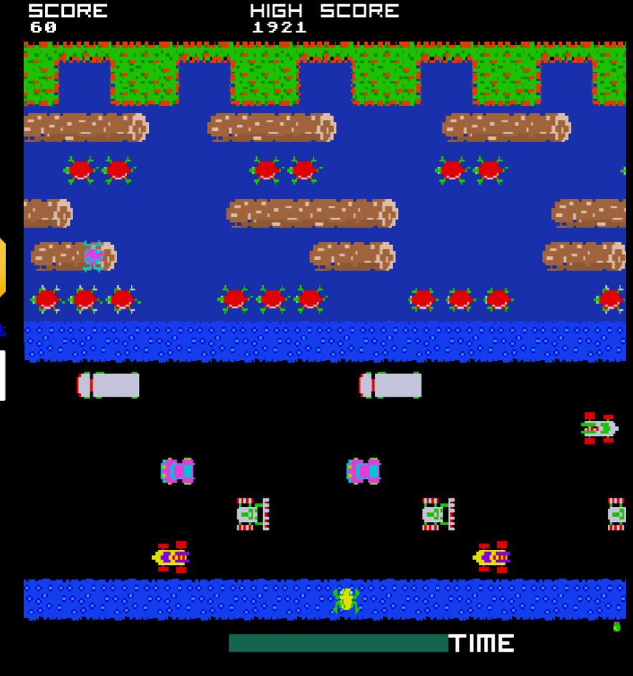

Frogger is an older arcade game made in 198. The aim of the game is to have the frog leap from one side of a lake to the other across floating logs. These logs are moving from side to side at various speeds. The frog them jumps across this landing and moving at the same speed of the log. If the frog the jumps into the water the player loses a life out of three lives. The player scores on speed of which they cross the lake and number of frogs that make it across the lake. The frog moves on the users arrow key presses moving one block for each key press. This version was found from <http://froggerclassic.appspot.com/>

I have chosen this as the bases of my project as it proves a good and familiar starting point for pupils. Most will have seen the game frogger or played it. It also integrates well with the idea of times tables each log carrying a different number, which is a multiple of the number the pupils picked.

### Comparison to another maths game

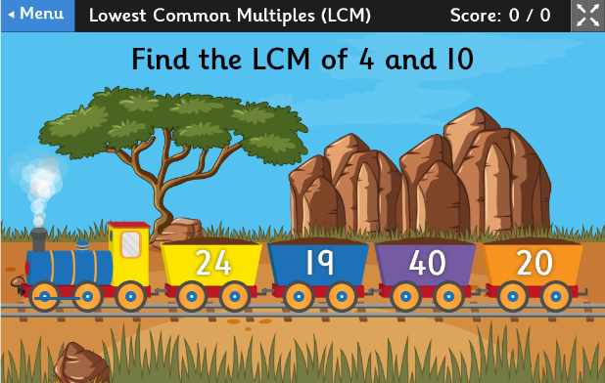This is a pre-existing e-learning tool for finding the lowest common multiple it was found on (<https://www.topmarks.co.uk/maths-games/multiples-and-factors>). In this game the user finds the lowest common multiple for two numbers out of four numbers. The game asks the student to find the lowest common multiple, then precedes to have a train bring on a multiple choice answers to the question. This relates to my design of my project in how the user is given a set amount of answers to question, and also is able to score based on the amount of answers they give. However it differs in its speed of game play.

### Why are e-learning tools used

IT resources are become more and more used with in schools why are people using them? I look what and why e-learning tools are becoming more and more used. First what is an e-learning tool, an e-learning tool is a program that trains/teaches on a computer or online. They tend to make good use of databases to see improvements or to see if a student or employee is fully trained. They improve on already available learning capabilities and may involve an interactive capability’s for the user. (<https://www.talentlms.com/elearning/technologies-used-in-elearning>). Firstly I looked at what there use is in schools today. I looked at why they are used ([https://www.stonegroup.co.uk/ict-resources-in-primary-schools/](https://www.stonegroup.co.uk/ict-resources-in-primary-schools/%20) ) there are some primary reasons why they are used. Firstly, it provides another resource for students to use when learning, being able to use them at school as well as at home. It also changes up the way students are learning instead of just using pen and paper to learn. This can stimulate the pupils and avoid the same type of lesson every day and help with concentrate so the students don’t become bored. Lastly, it has very good use for testing and examine the students it a quick and easy way that doesn’t require the teacher to suddenly mark a class full of papers. This can put strain on the teacher to quickly mark a class room full of students also this ensures that test aren’t marked incorrectly.

## Data Flow Diagram

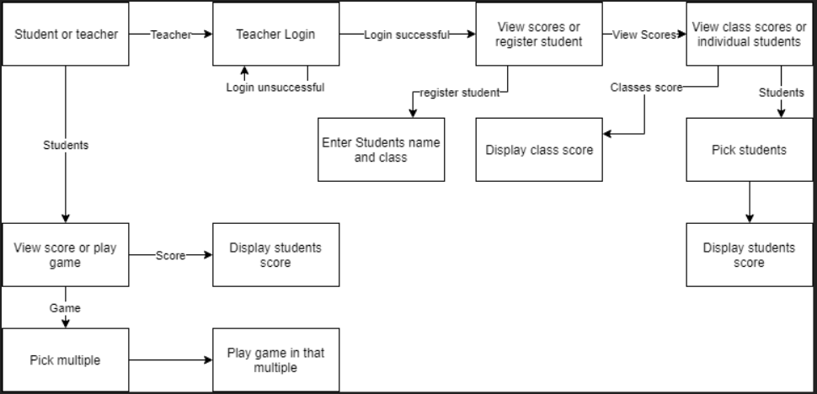

## Research

### Interview

Background before interview: I am developing a e-learning tool to help students in KS1 learn their times tables. The game will centre around the old arcade game frogger where a frog jumps over river on logs to get to the other side. On the logs will be multiples of a number which they must jump on and not wrong ones. I was wondering if you would be able to answer a few questions for me about this game if you have any more input or ideas that would be very useful.

Q: How do students currently practise their times tables

Q: Would a computer game be of interest when practising times tables

Q: Is it time consuming to mark multiple papers

Q: Do students use computers when practising maths

Q: Would it be useful to be able to see all the students progress and the classes as a whole

Q: Do you have to teach at different paces for different students

Q: Would it be useful to have the students practise specific times tables

Q: Is there anything you may find use fully for a maths game when teaching times tables

### Year 2 teacher

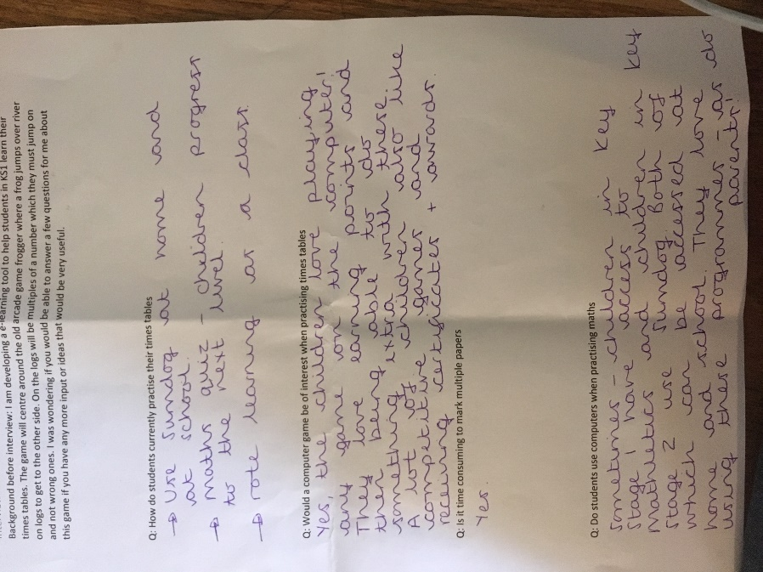

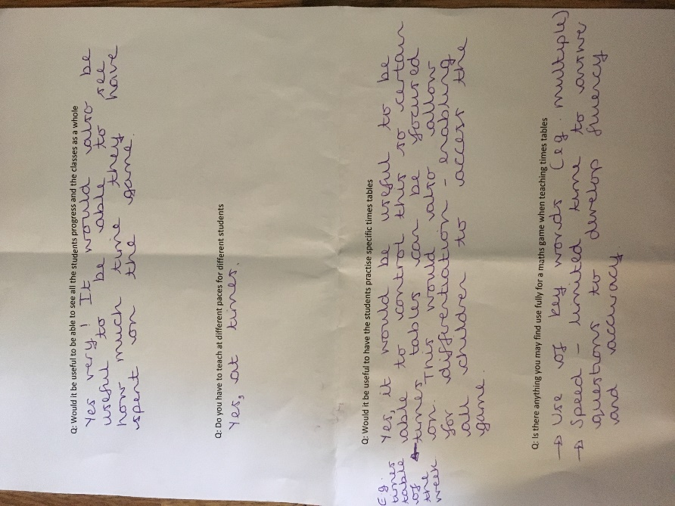

### Year 3 teacher

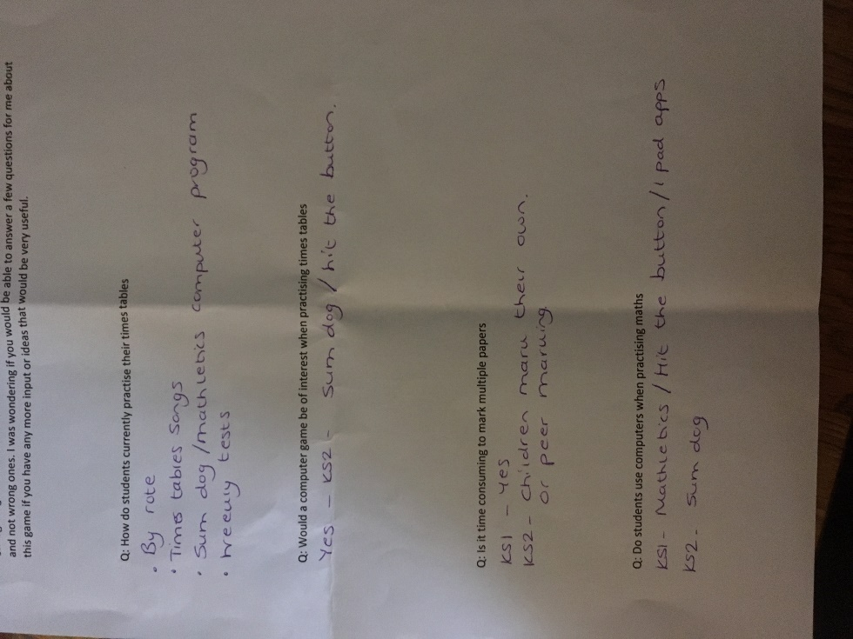

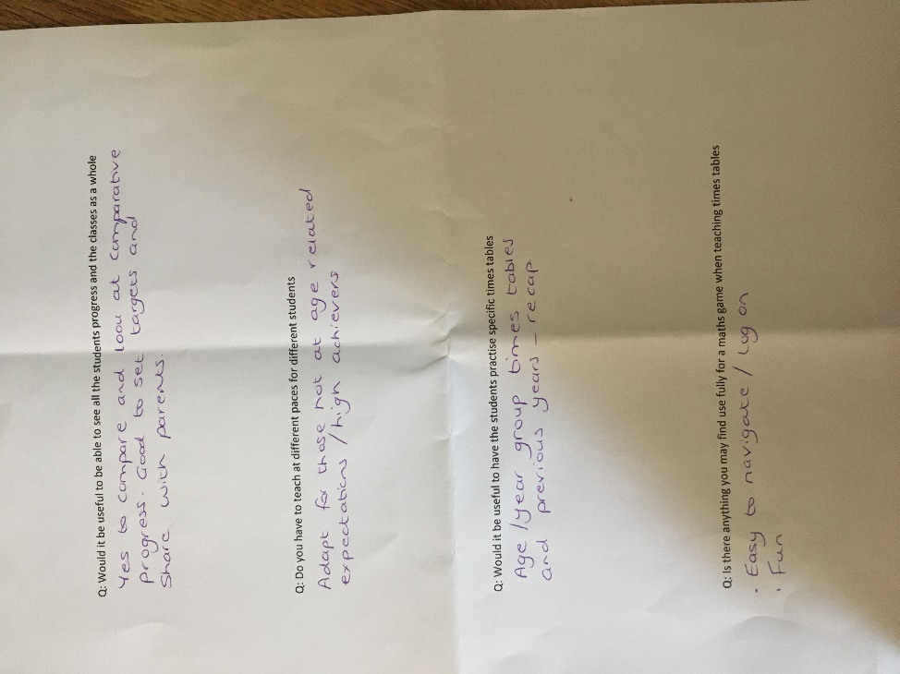

### Deputy head

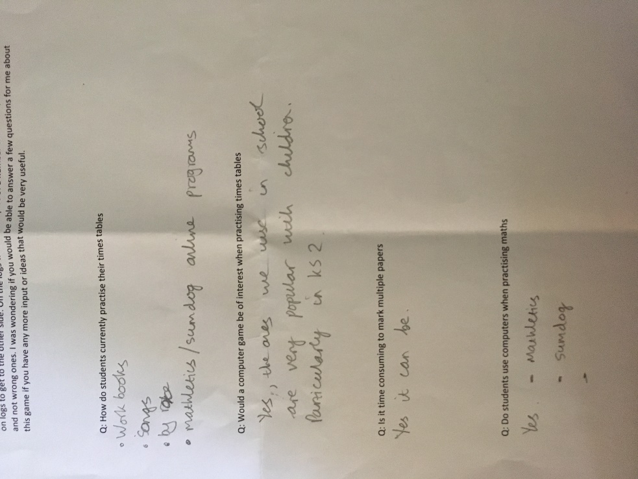

### Improvements after interview

After this interview I can see the school already uses interactive games for pupils and the teacher appreciate them a lot. From what the teachers would like the program to achieve to be able to let the students view their score in comparison to the rest of the class. This will become like a league table and motivate the students to try come top of the class. They would also like for the program to include a home learning element, this may mean an executable gets sent to the students and connects the student’s computers to a single database at home or in school. Lastly, they would like the game to have a speed aspect to it to increase fluency and skill with in the class.

## Objectives

### Teacher side

1. Login for admin and teacher
2. Admin
   1. Displays all students
   2. Allows to add teacher
3. Display students from menu
   1. Display all students at once – students can see how well they are doing in the class
   2. Remove Students
   3. Average score of the class
   4. Change multiple selected
4. Add student
   1. Create unique username
5. Add teacher from admin
   1. Creates unique username

### Student Side

1. Login
2. User Friendly
3. Displays pause screen
   1. Select multiple to work on
   2. Start game
4. Game played
   1. Logs created with factors of selected multiples
   2. Score increase
5. Scores saved to backend database